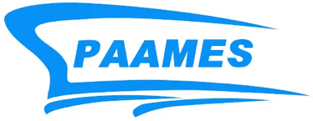
PAAMES & AMEC 2010 and 2025
SNAMES is part of a group of seventeen member organisations that form the Pan Asian Association of Maritime Engineering Societies (PAAMES) that was established in the year 2004 to meet the following objectives:
- Promoting science and technology in maritime engineering,
- Supporting the development of maritime industry,
- Exchanging scientific information,
- Improving the status of maritime engineers, and
- Enhancing the cooperation and collaboration among member organizations of PAAMES
These maritime engineering-related engineering organisations come from countries like China, Japan, Korea, Singapore, Taiwan, Hong Kong, Russia and the UK and gather once every two years at the Advanced Maritime Engineering Conference (AMEC).
In the year 2010, SNAMES hosted the AMEC 2010 and 4th PAAMES Forum from 6th to 8th December 2010. It was held at the National University of Singapore (NUS) with the theme “Recent Developments in Maritime Safety and Environmental Protection”. Over 80 papers covering wide-ranging topics from hydrodynamics, offshore structures, and technologies to shipboard machinery and systems and environmental protection were delivered. The conference was attended by more than 200 delegates from 11 countries which was the largest conference organised by SNAMES in its history.
The AMEC 2010 was organised by the Singapore Organising Committee (SOC) which was made up of several senior SNAMES members led by the then SNAMES President, Mr Kenneth Kee.

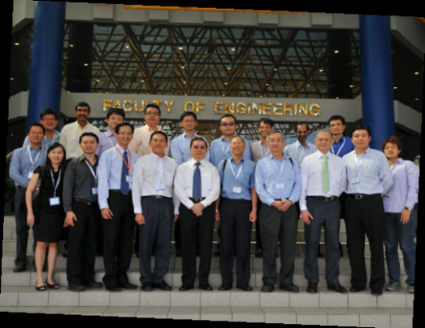
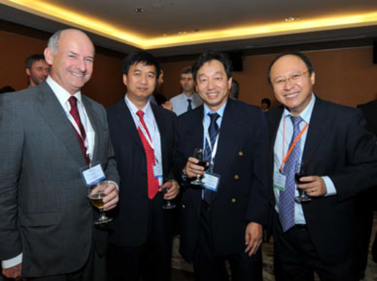
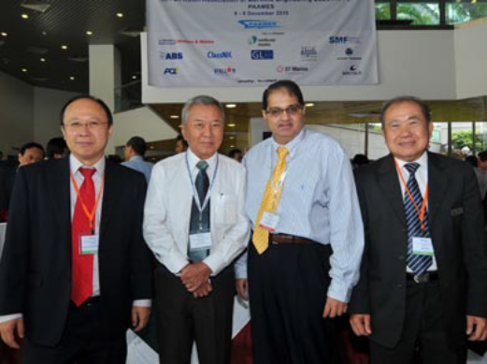
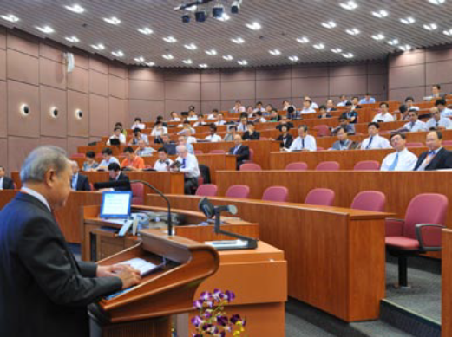
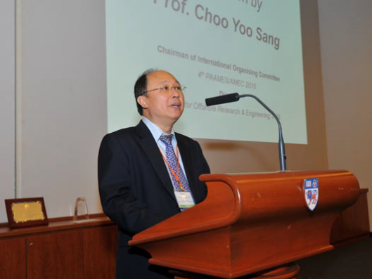
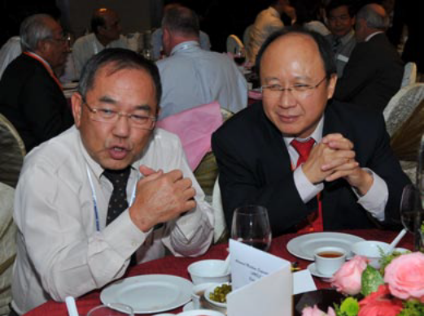
Photographs from AMEC2010

In 10-12th December 2025, SNAMES again welcomed our friends from the PAAMES organisations by organising the AMEC 2025 and the 11th PAAMES Forum at the National University of Singapore (NUS).
The conference was organised by the Singapore Organising Committee (SOC) chaired by A/Prof Ang Joo Hock and Dr Paul Ong with members consisting of volunteers drawn from the SNAMES membership.
A total of 240 delegates attended the three-day conference with the theme “Innovations for a Sustainable Maritime Future” and saw 82 high-quality papers presented. Site visits to the Technology Centre for Offshore and Marine, Singapore (TCOMS) and Singapore Maritime Gallery were organised to let the overseas delegates know more about Maritime SG. On the last day, a conference dinner was held in conjunction with the 51st Anniversary Dinner at Grand Copthorne Waterfront, which allowed networking between local maritime professionals and visiting overseas delegates. As part of the final highlight, 14 delegates enjoyed a memorable post-conference river cruise along Singapore’s iconic waterfront onboard WaterB’s Pyxis R, a new solar-powered electric vessel.

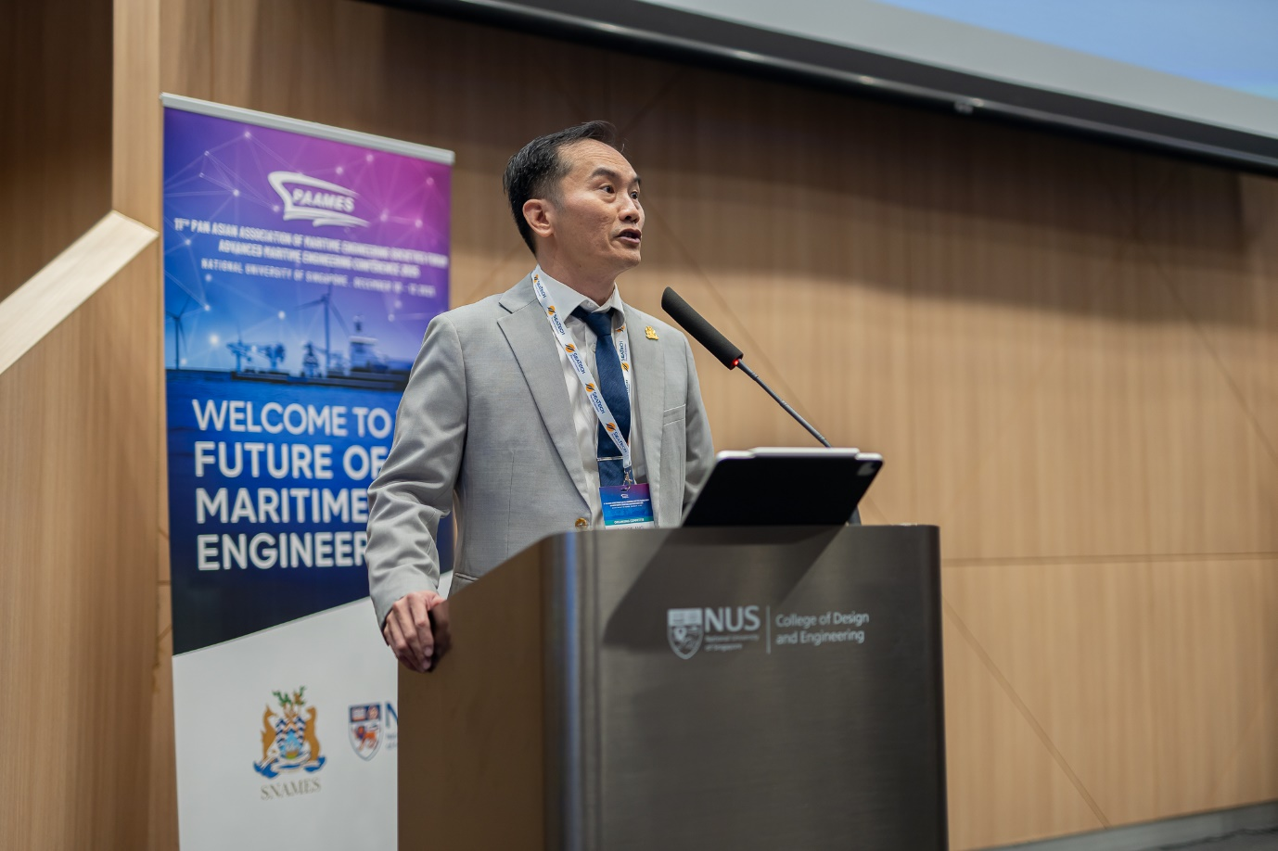
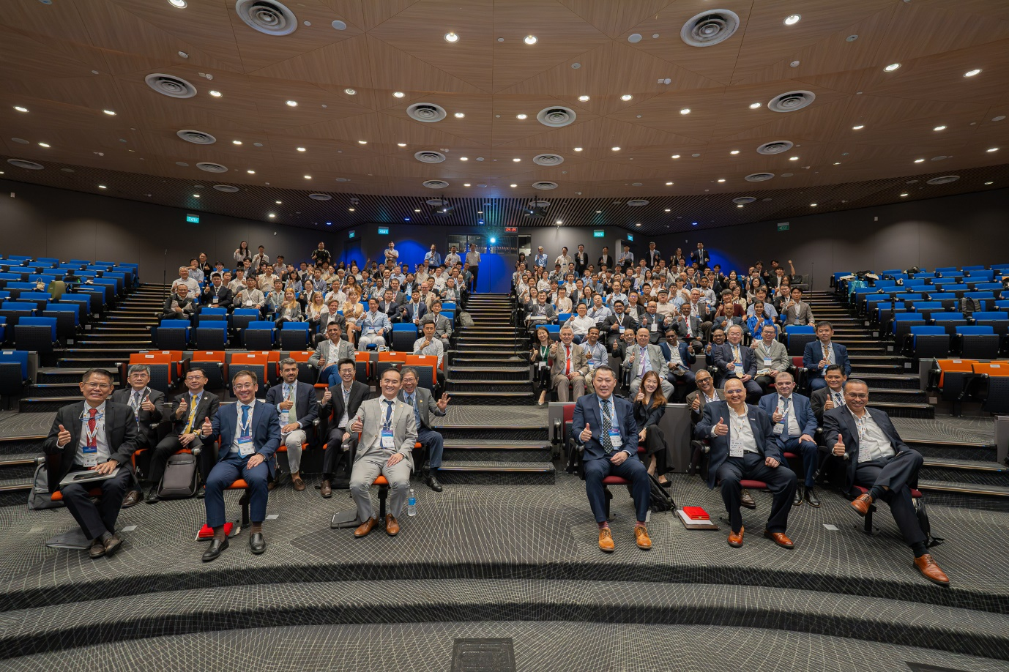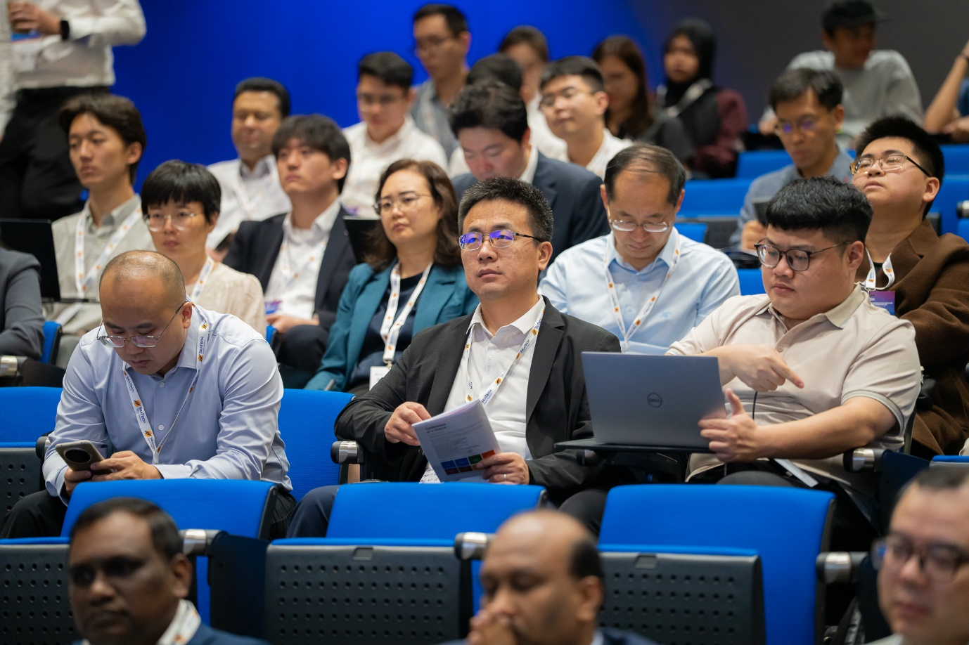
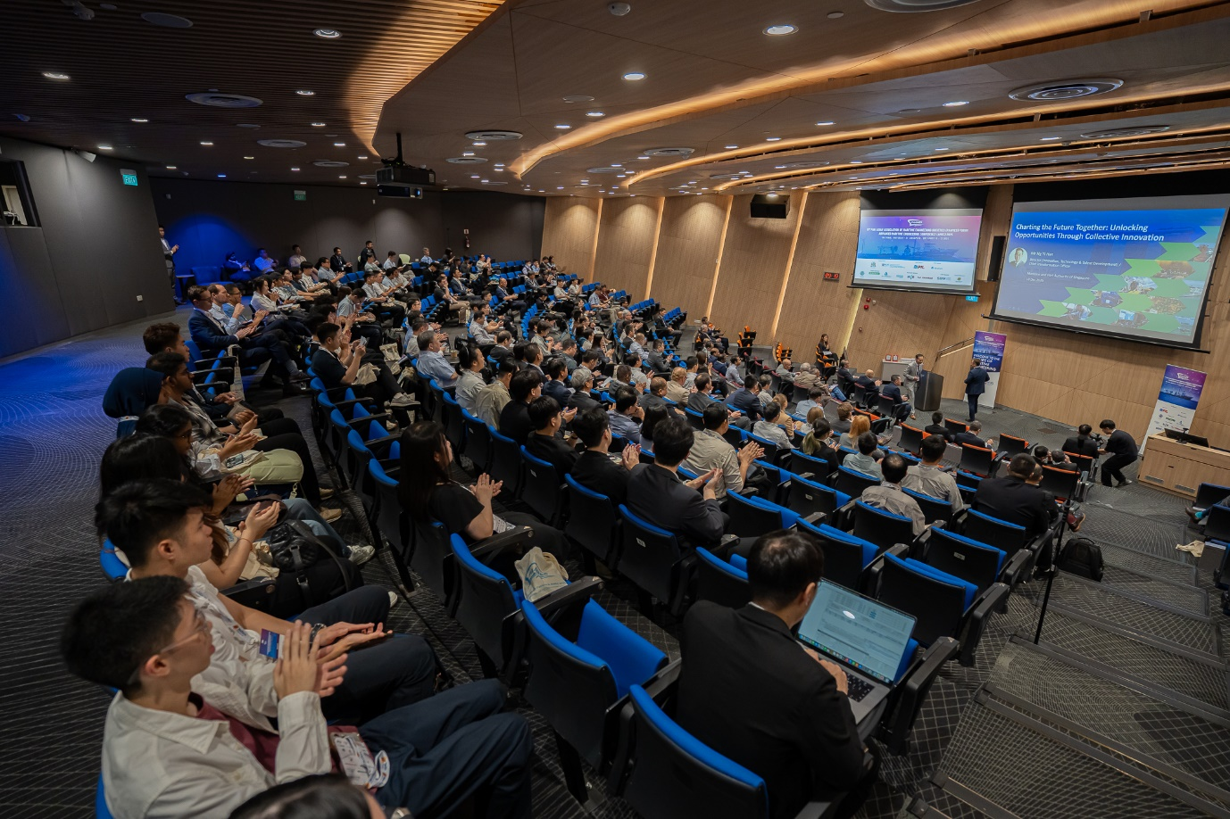
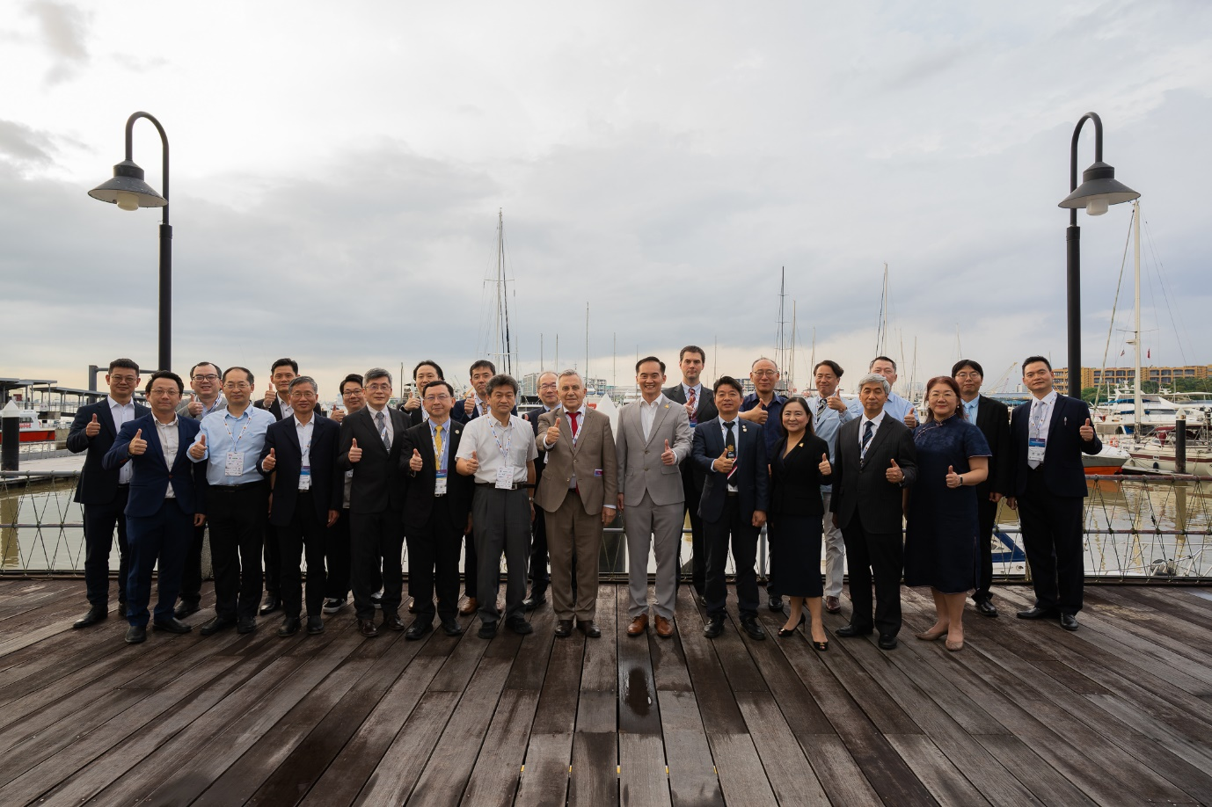
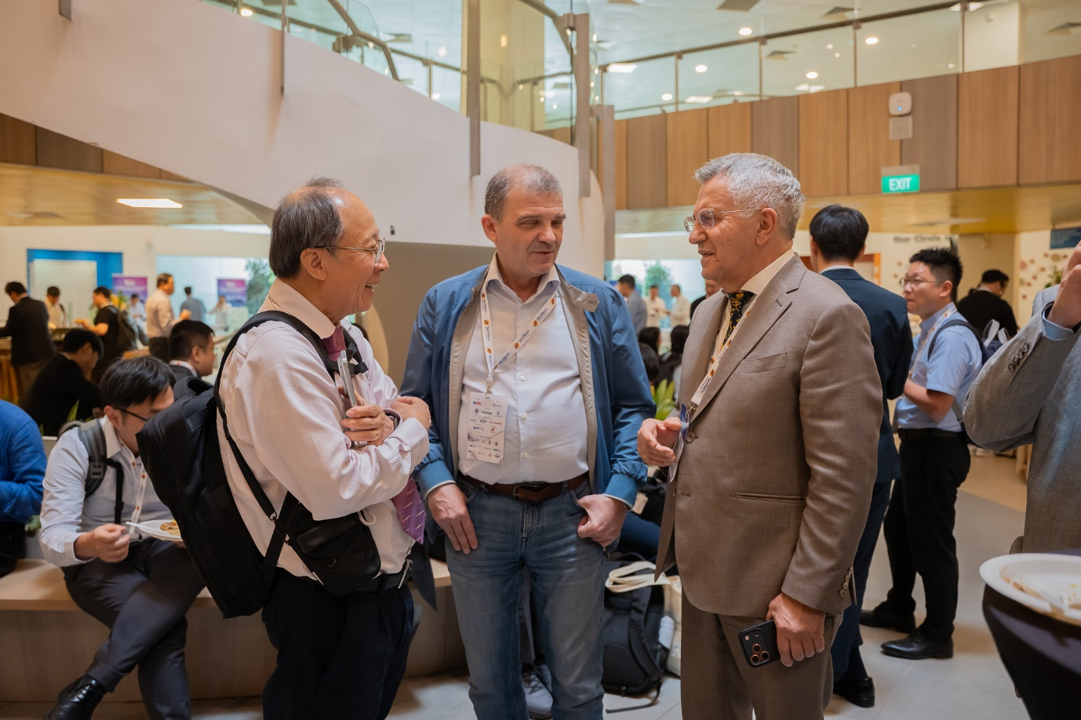
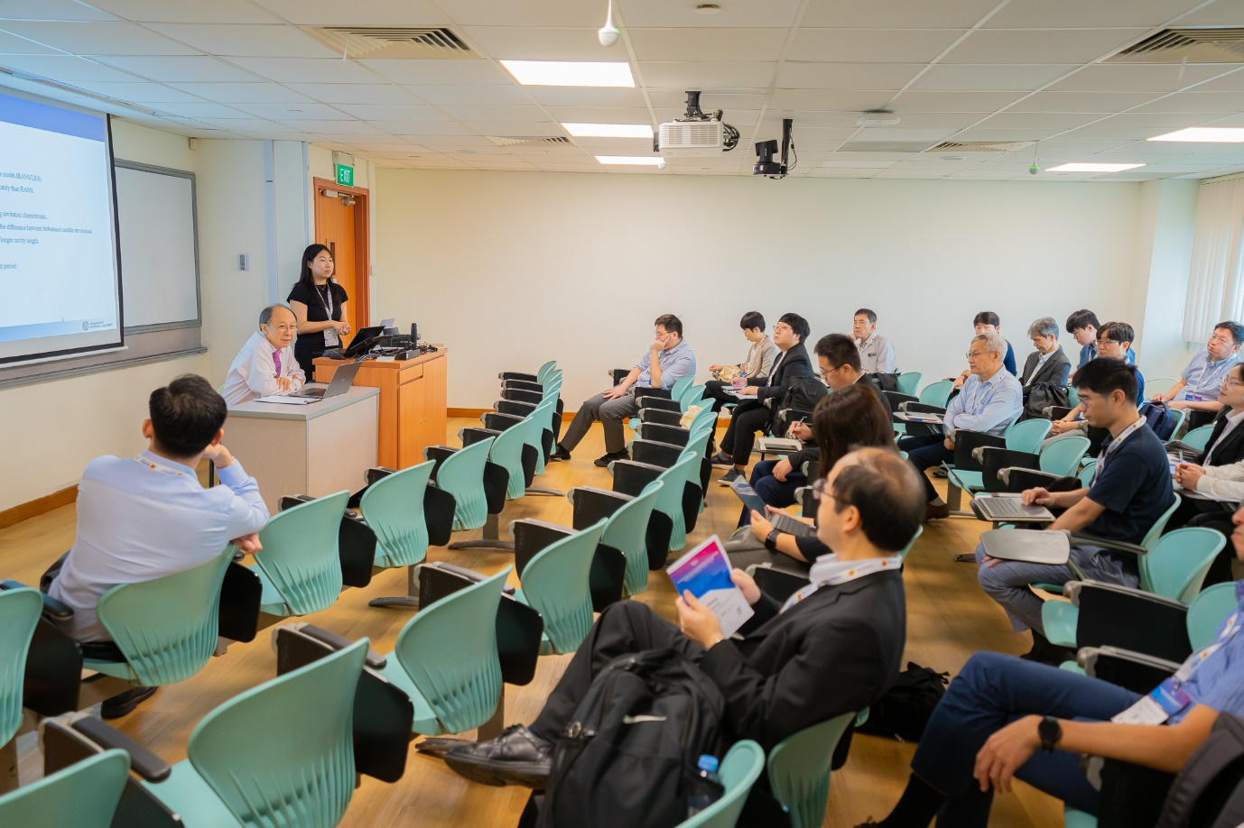
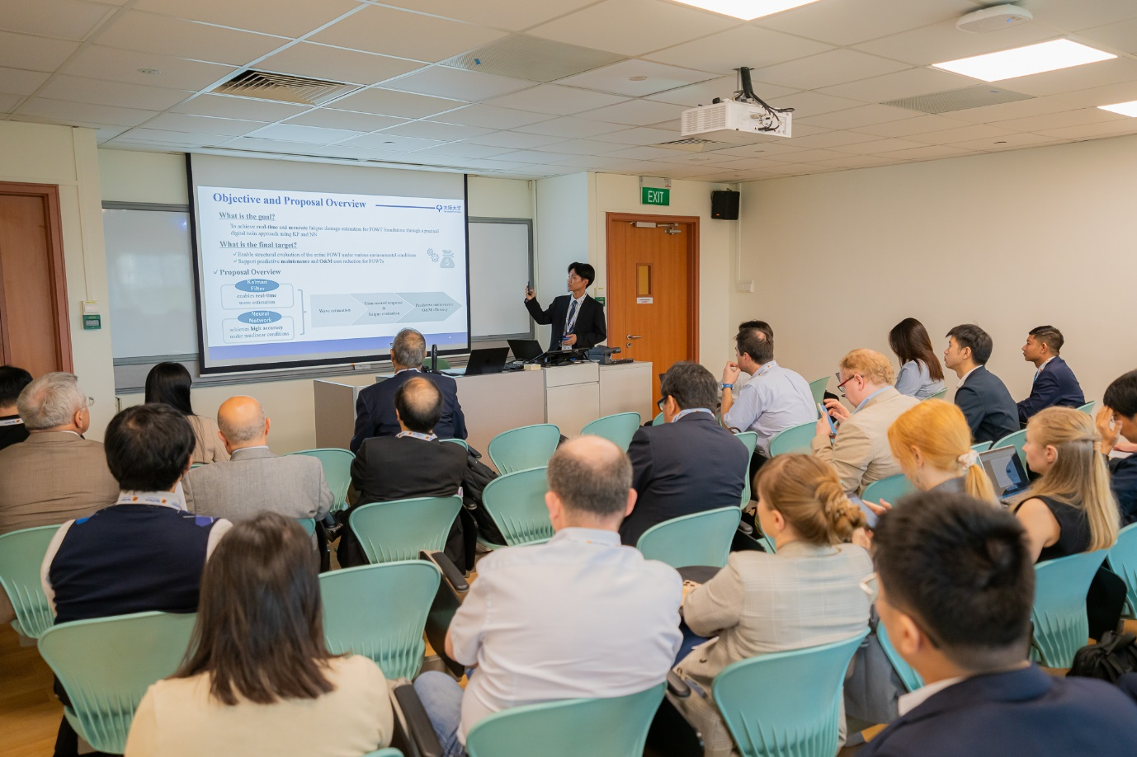
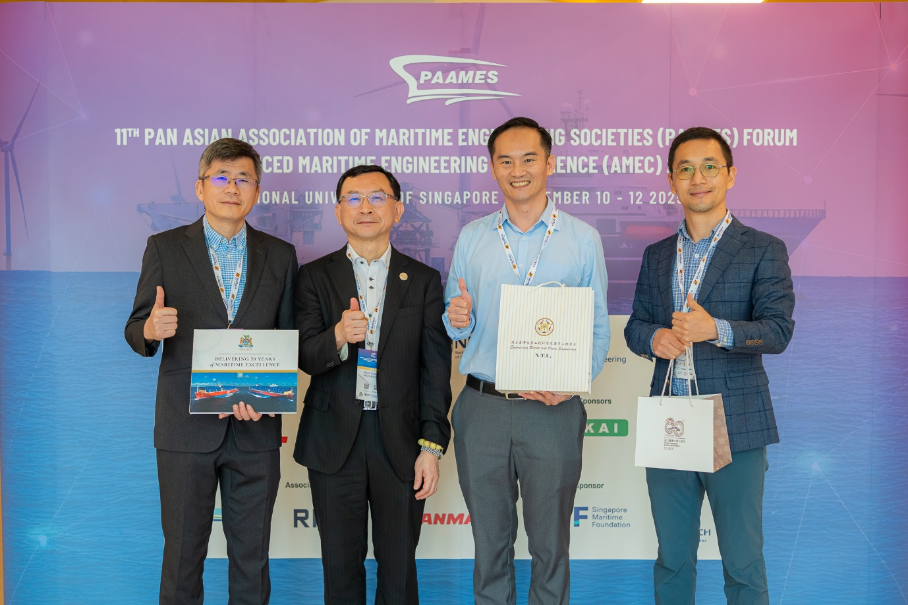

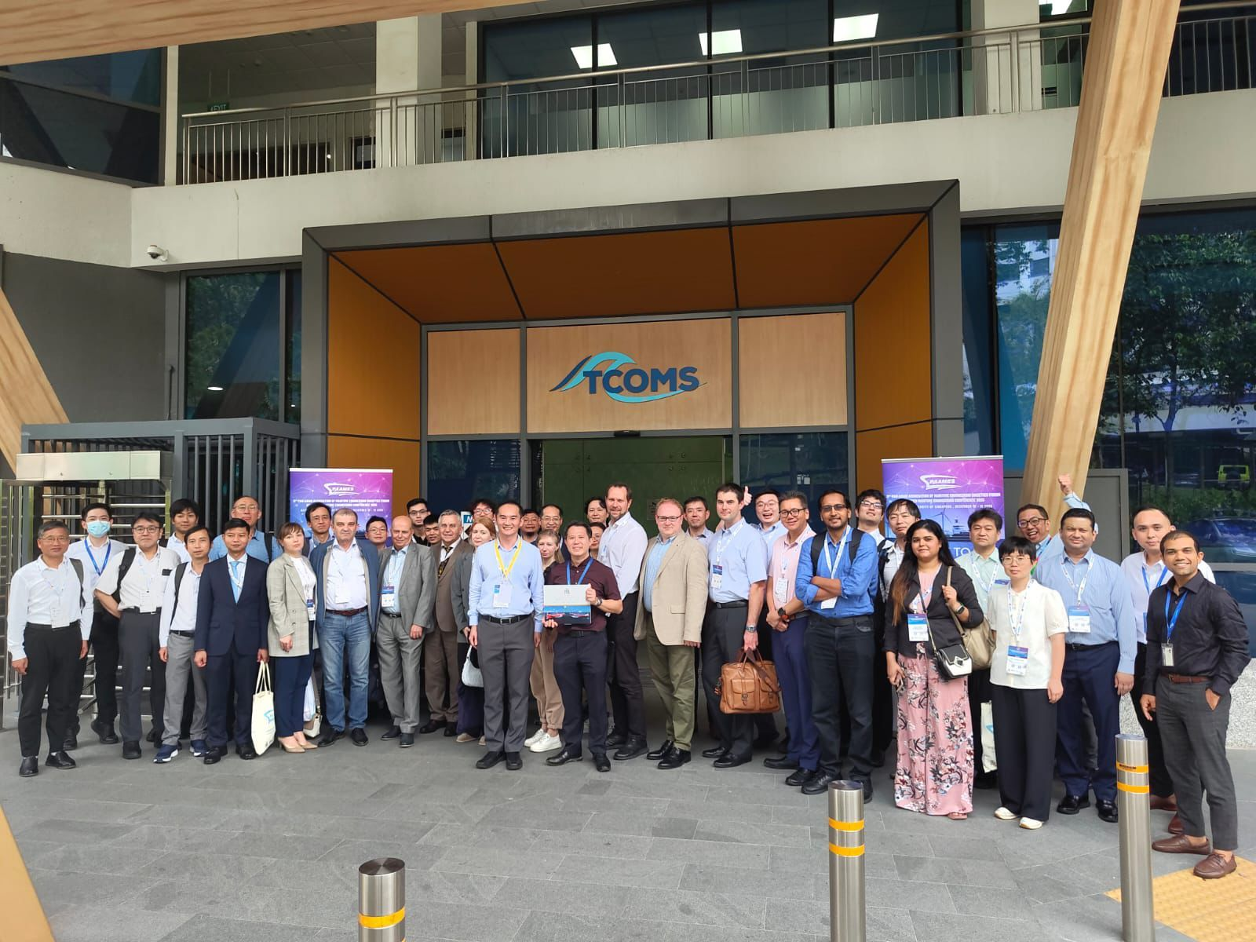
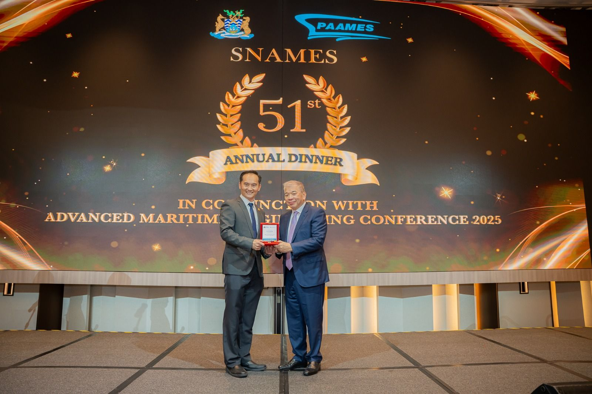
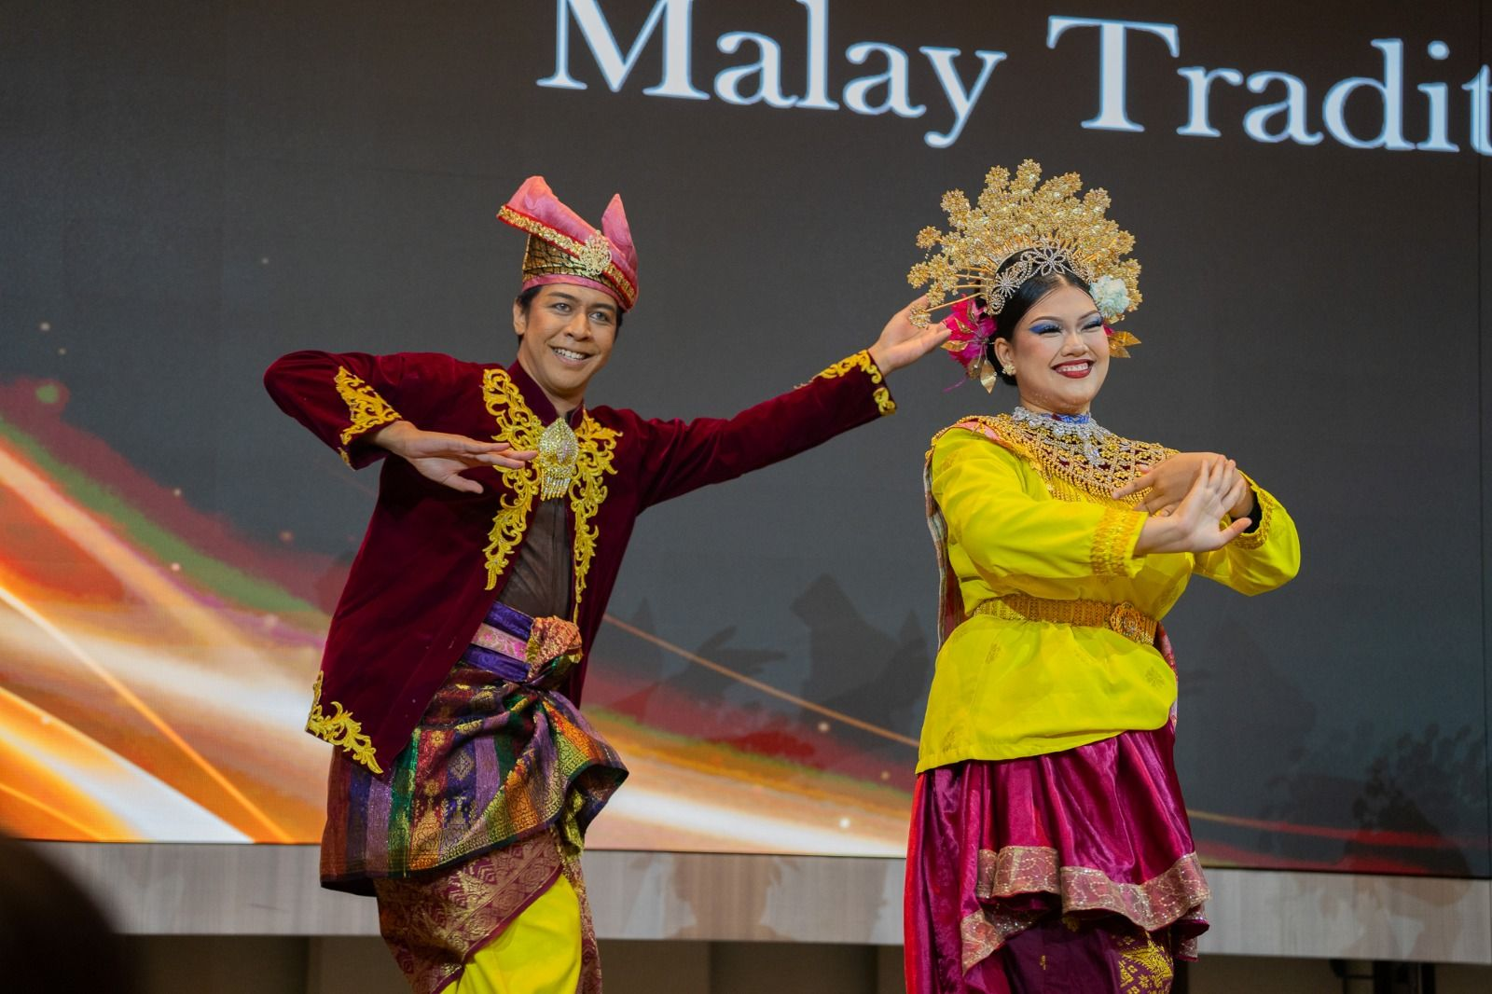
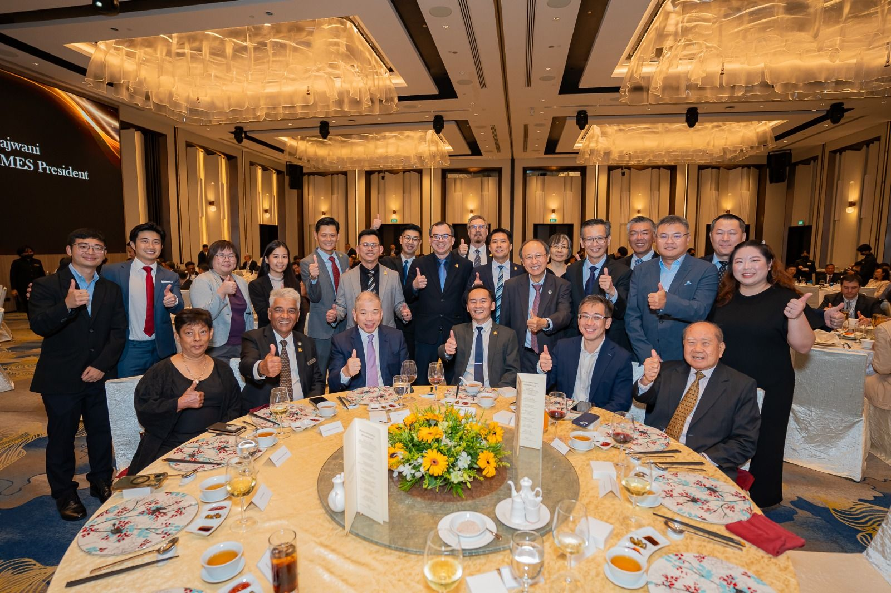
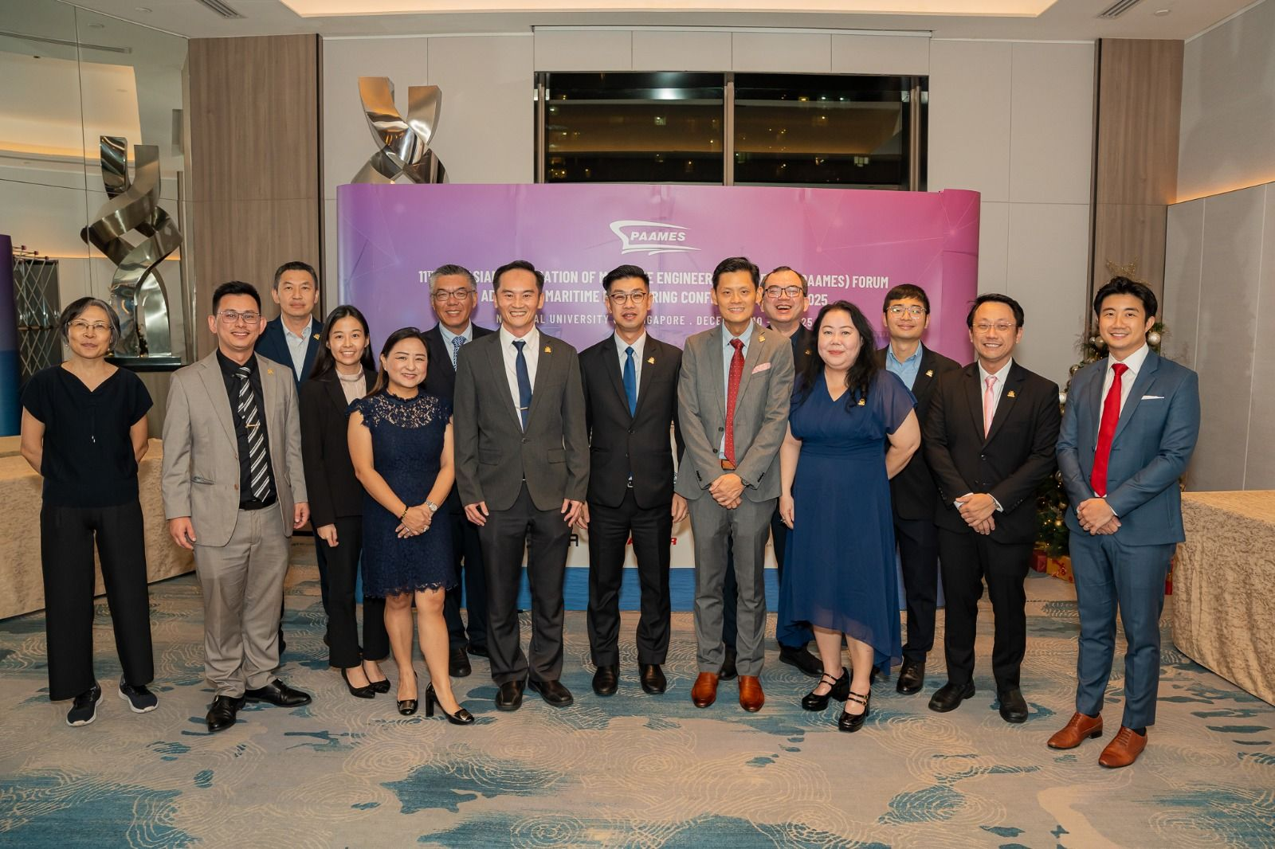
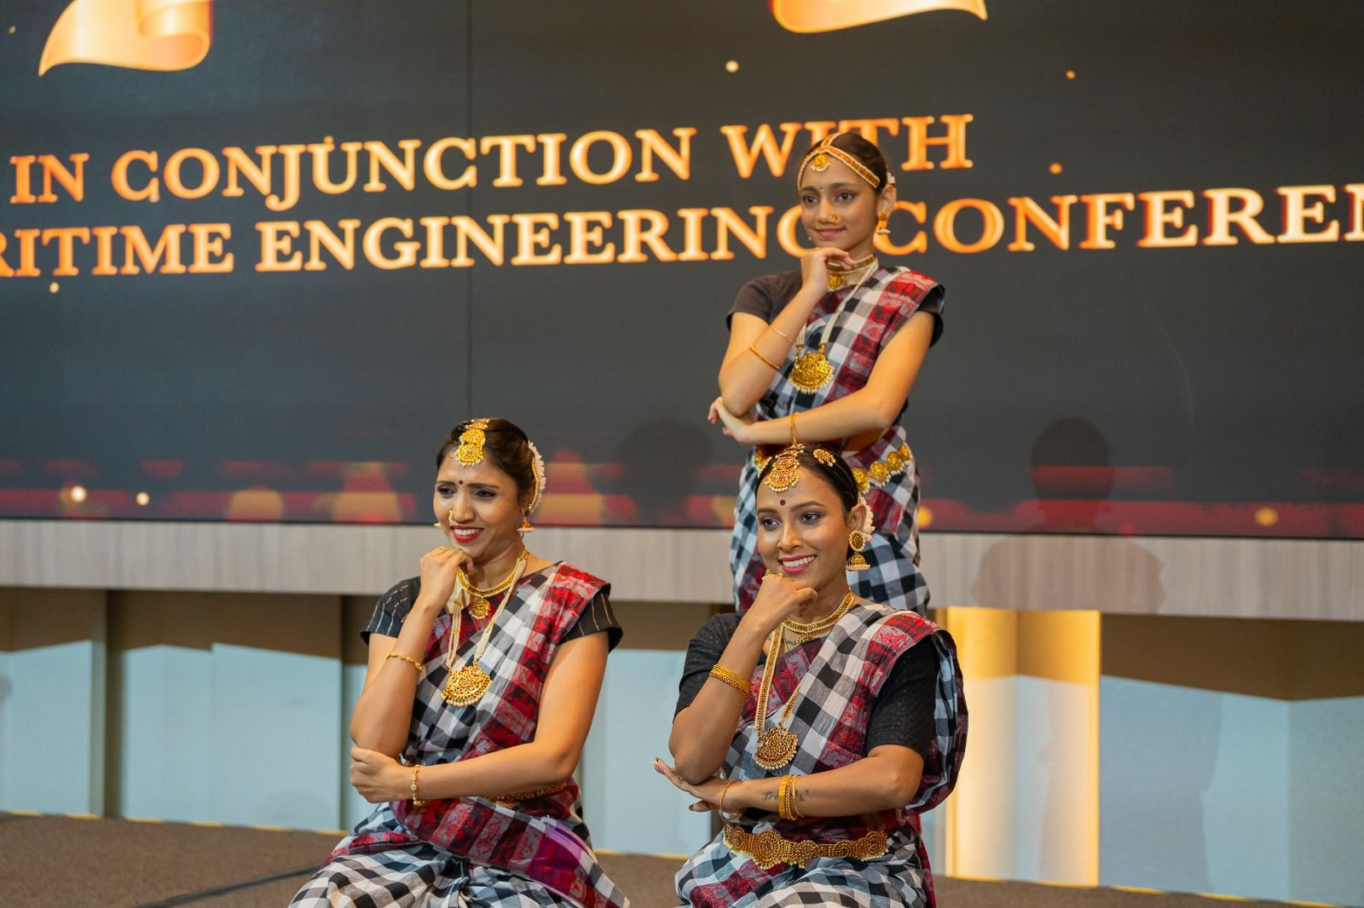
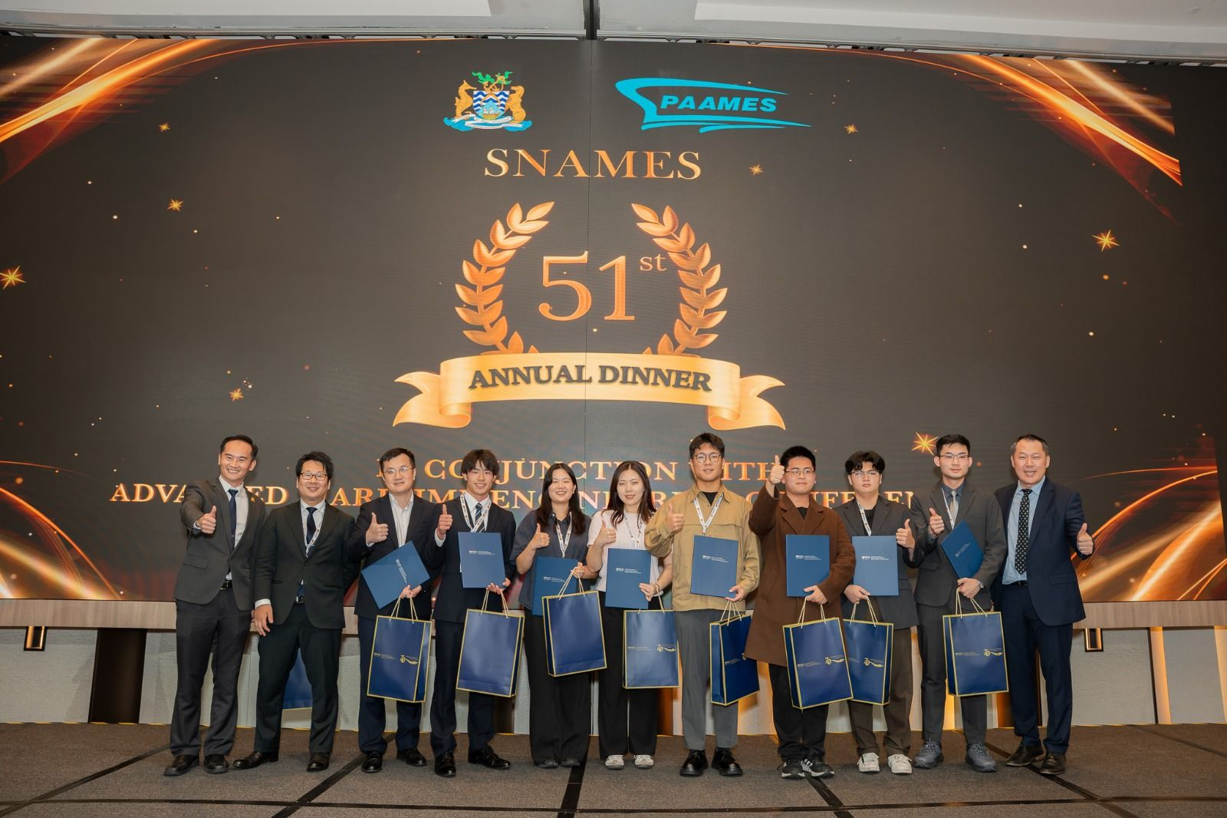
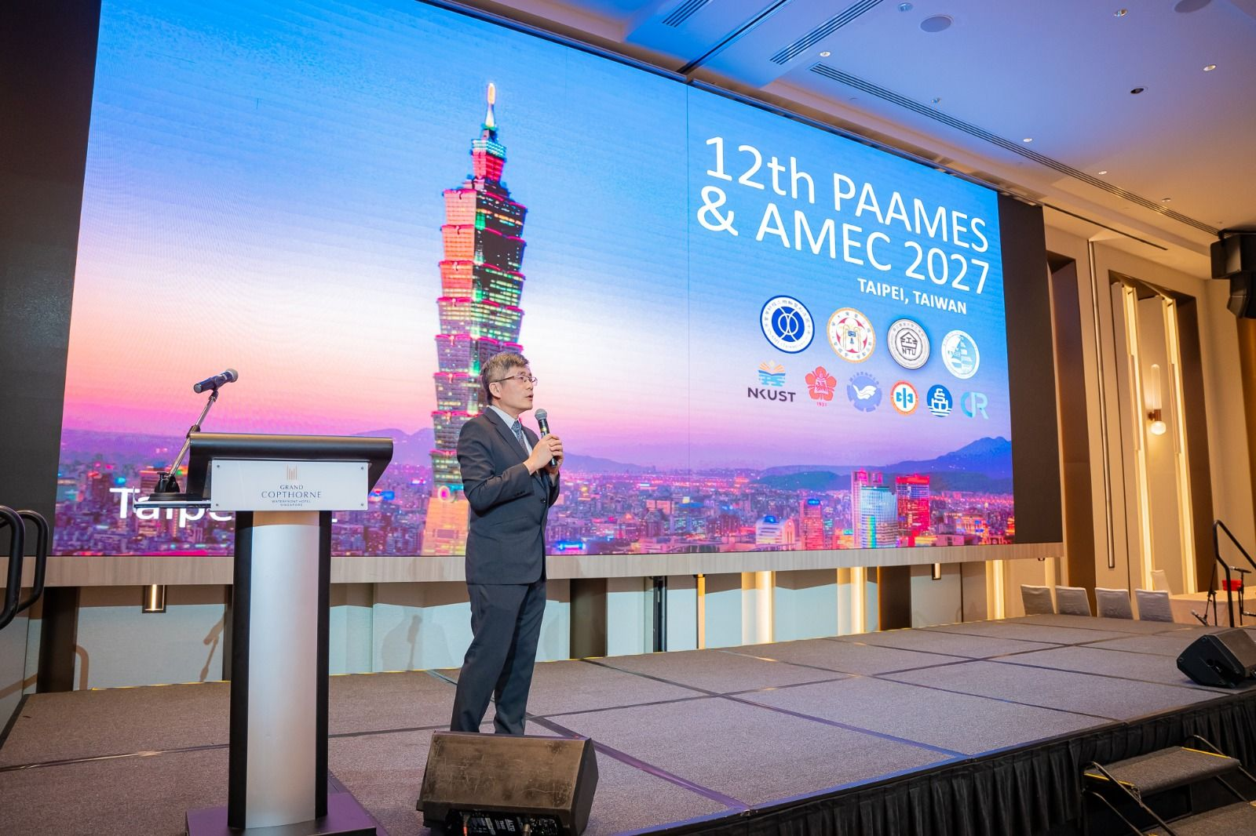
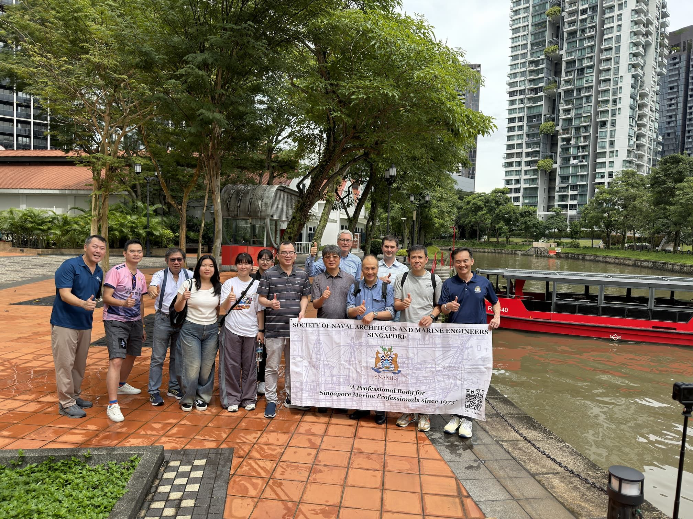
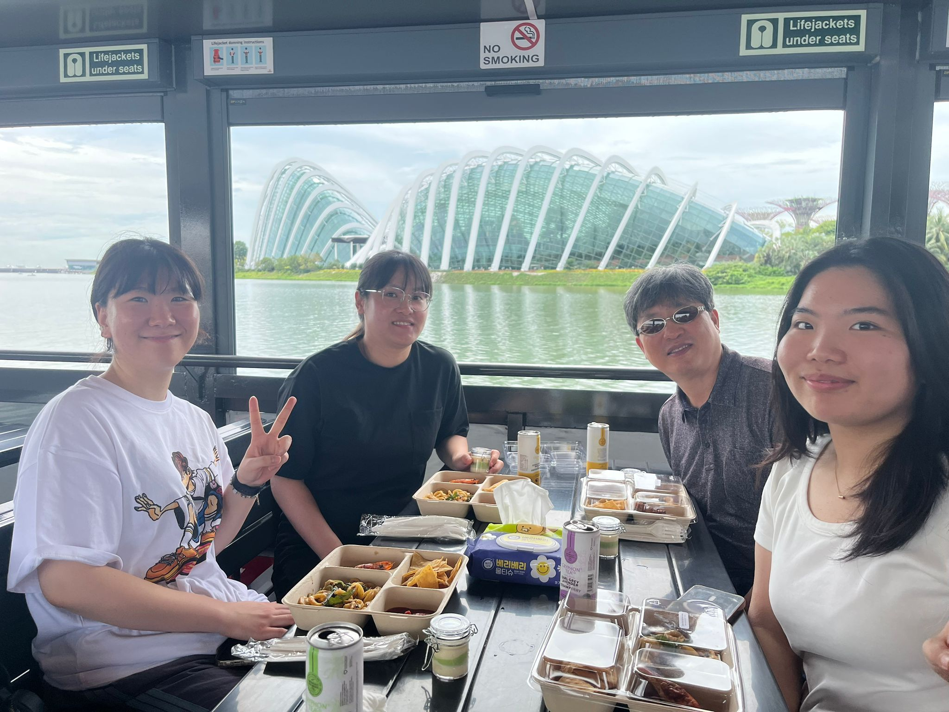
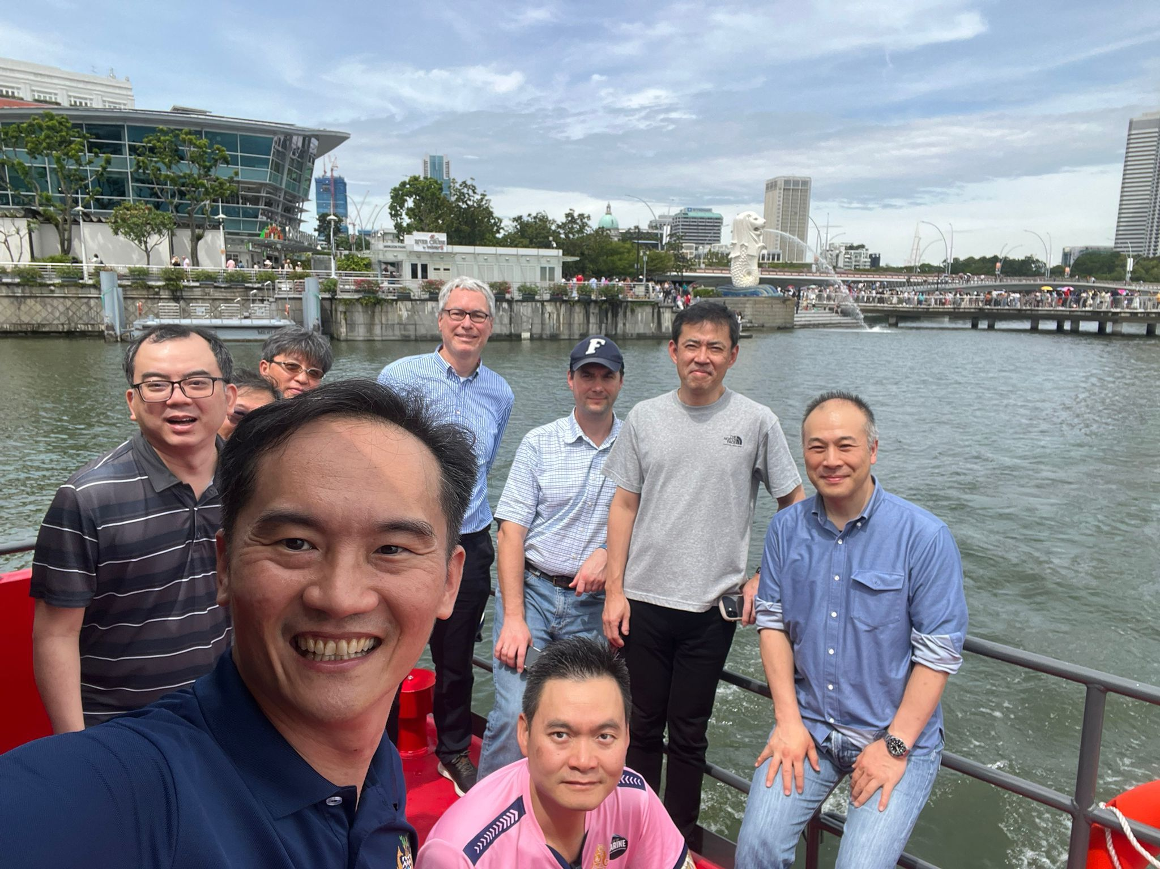
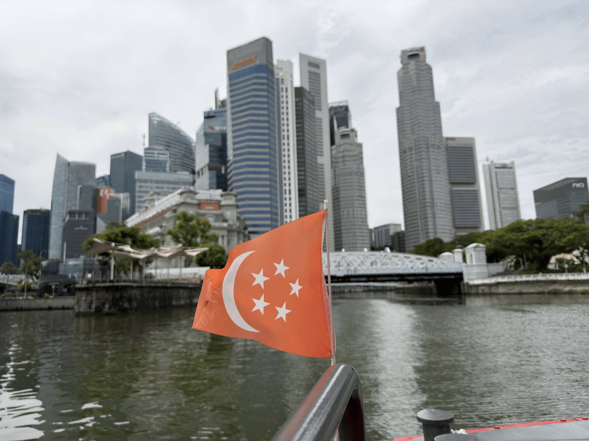
Photographs from AMEC2025

PAAMES website:
http://www.paames.org/
AMEC 2025 Conference Proceedings
https://eresources.nlb.gov.sg/publicationsg/details.html?uuid=867935b5-4bdf-4681-afbc-789e391d9aa4

